Participants were within a much smaller age group (18-26) as well as participants also all living in shared housing/communal living space conditions. The justification for these participant requirements were because firstly, the large majority of people living in shared housing/communal living space conditions were young adults, often students. Secondly, in the conducted research it was found that users managing their own energy or water supply systems were more likely to co-manage their resources and consumption" (Strengers, 2011). Additionally, it has been seen that in family households that individuals such as children often felt no responsibility in conserving energy, therefore it seemed most appropriate to focus this questionnaire towards participants who were more likely to feel responsible for managing their energy consumption.

**What is your relationship to your household members?**

P1: Shared housing with 3 university students (friends)

P2: Shared housing with 2 random people (acquaintances)

P3: Shared housing with boyfriend and 2 friends (boyfriend and close friends)

P4: Shared housing with 5 university students (acquaintances)

P5: Shared housing with 5 university students (some acquaintances and some friends)

P6: Shared housing with 3 university students (friends)

P7: Shared housing with 2 friends (close friends)

P8: Shared housing with 2 friends (close friends)

P9: Shared housing with 2 friends (close friends)

P10: Shared housing with 3 university students (friends)

**What is the living arrangement in your share house?**

P1: University student accommodation townhouse (Varsity), 2 bathrooms 4 bedrooms

P2: Suburban house, 1 bathroom 3 bedrooms

P3: Suburban house, 2 bathrooms 3 bedrooms

P4: Suburban house, 3 bathrooms 6 bedrooms

P5: University student accommodation Highrise dorm style (Urbanest), 6 bathrooms 6 bedrooms

P6: University student accommodation townhouse (Varsity), 2 bathrooms 4 bedrooms

P7: Unit, 2 bathrooms 3 bedrooms

P8: Unit, 2 bathrooms 3 bedrooms

P9: Unit, 2 bathrooms 3 bedrooms

P10: Student Accommodation Unit, 2 bathrooms 4 bedrooms

**How often do you cook with the people you live with?**

P1: Often, 3 times a week.

P2: Never

P3: Very often, with boyfriend most days, with other friends a few times a week

P4: Rarely

P5: Rarely

P6: Very Often

P7: Often

P8: Often

P9: Very often

P10: Never

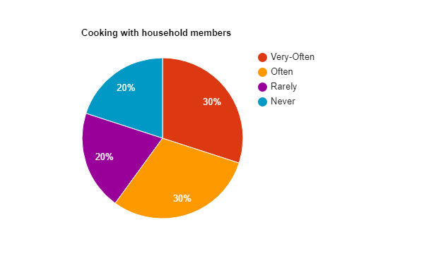

**How often do you cook alone?**

P1: Sometimes, 3-4 times a week

P2: Always

P3: Rarely

P4: Almost always

P5: Very Often

P6: Often

P7: Not very often

P8: Sometimes

P9: Not very often

P10: Always

**How often do you do laundry as a communal task, rather than washing your own laundry separate to those you live with, and are they typically full loads?**

P1: Often, almost always with my housemates, not typically full loads.

P2: Never, always my own laundry, most often full loads.

P3: Very often, typically full loads

P4: Never, always my own laundry, sometimes full loads.

P5: Rarely, sometimes do laundry with 1 or 2 room mates I am close with, always full loads.

P6: not very often, mostly full loads

P7: Often, mostly with housemates, typically full loads.

P8: Often, mostly with housemates, typically full loads

P9: Often, typically full loads.

P10: never, full loads.

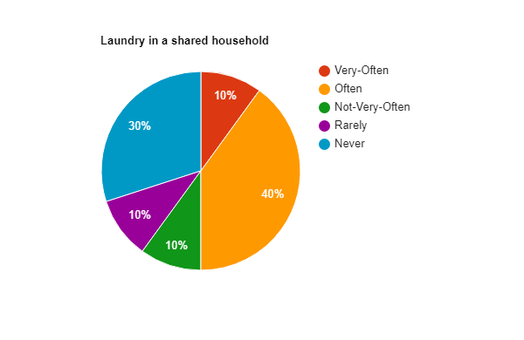

**How often do you use the dryer?**

P1: Always

P2: Never

P3: Not very often

P4: Always

P5: Always

P6: Rarely

P7: Always

P8: Always

P9: Always

P10: Never

**How often do you use the heater?**

P1: Never, we don’t have one

P2: Rarely

P3: Rarely

P4: Never

P5: Never

P6: Never

P7: Never

P8: Never

P9: Never

P10: Never

**How often do you use the air-conditioner?**

P1: Never, we don’t have one

P2: Sometimes

P3: Sometimes

P4: Sometimes

P5: Often

P6: Often

P7: Sometimes

P8: Sometimes

P9: Sometimes

P10: Rarely

**How often do you use the fan?**

P1: Always, every day but only when I’m home

P2: Very often, on most days

P3: Very often, on most days

P4: Often

P5: Very often

P6: Always

P7: Often

P8: All the time

P9: All the time

P10: Often

**How often do you use streaming media such as the TV or Netflix?**

P1: Very often, daily

P2: Very often, daily

P3: Almost always, daily and for most of the day

P4: Very often, daily

P5: Very often

P6: Very often

P7: Very often

P8: Very often

P9: Very often

P10: Very oftne

**How often do watch streaming media with the people you live with, as opposed to watching it by yourself using your own device (i.e. Netflix on your laptop in your own room)?**

P1: Not very often, once a week, otherwise by myself in my room

P2: Never, always on my own in my room

P3:Not very often, otherwise on my computer or on TV in my room.

P4: Never

P5: Rarely

P6: Not very often

P7: Often

P8: Often

P9: Not very often

P10: Never

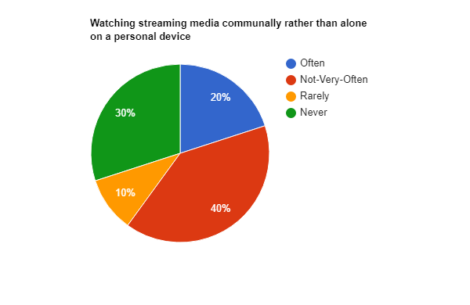

**Do you have an appliance in your room that would in a typical family household be considered more of a communal appliance (i.e. TV, fridge)?**

P1: Yes, there is a TV in my room

P2: Yes, there is a bar fridge in my room

P3: Yes, there is a TV in my room

P4: No

P5: Yes, Tv

P6: Yes, TV and bar fridge

P7: No

P8: Yes, TV

P9: Yes, Tv

P10: No

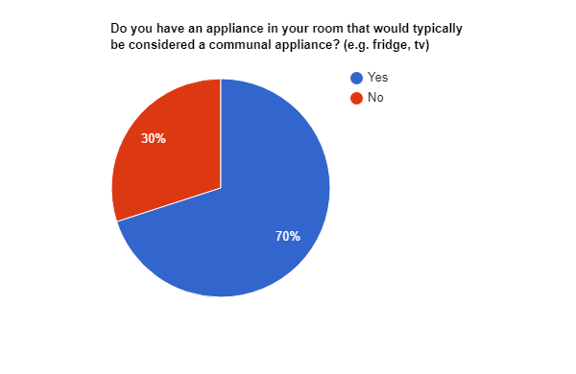

**If you answered yes to the previous question, what is the reasoning for this/these appliances and if applicable, how often are they used?**

P1: So I can play my own games on it and watch stuff on it, Sometimes.

P2: To store my own food in, as I don’t want others stealing what I have purchased.

P3: So I can play games, watch show, etc in my own time and with my own privacy.

P4: N/A

P5: Video games

P6: For personal use, to watch what I want and to store foods I want to eat without people using them

P7: N/A

P8: Tv for video games, etc

P9: Video games

P10: N/a

**How often do you communicate with other household members about conserving energy?**

P1: Never

P2: Never

P3: Rarely

P4: Never

P5: Never

P6: Never

P7: Not very often

P8: Never

P9: Never

P10: Never

**How often do you use the dishwasher as opposed to washing the dishes yourself, and if you use the dishwasher, is it typically full when being used?**

P1: Sometimes, Dishwasher is almost always full.

P2: Never, don’t have a dishwasher

P3: Often, Dishwasher is almost always full.

P4: Never, don’t have a dishwasher

P5: Never, just wash my own dishes as there usually aren’t much

P6: Often, Dishwasher is always full

P7: Very often, dishwasher is always full

P8: Very often, dishwasher is always full

P9: Very often, always full

P10: Never

**How long are your showers typically? Is there much variation in shower time between household members (i.e., do they typically shower for longer or shorter times)?**

P1: Reasonably short, under 5 minutes, A lot of variation, some household members shower for much longer periods of time.

P2: Between 5-10 minutes, Little variation, all household members typically keep their showers under 10 minutes.

P3: Under 10 minutes most of the time, lots of variation, some household members will shower for 20 minutes or so.

P4: A little long, 10 minutes, most members shower for that long anyway.

P5: Pretty short, usually 5 minute or so, lots of variation, some have very short showers, others have long showers.

P6: Under 10 minutes, everyone is pretty much the same

P7: Short, one housemate has longer showers

P8: Under 7-8 minutes mostly, lots of variation.

P9: Short, big variation

P10: Short, small variation

**To what degree do the members of your household ensure that areas they are not using consume a minimal amount of energy (i.e., turning lights off and making sure appliances are switched off when they go to their room after using the kitchen)?**

P1: A good degree

P2: A reasonable degree

P3: A reasonable degree

P4: Could be better

P5: A good degree

P6: Could be better

P7: Could be better

P8: A reasonable degree

P9: Could be better

P10: A reasonable degree

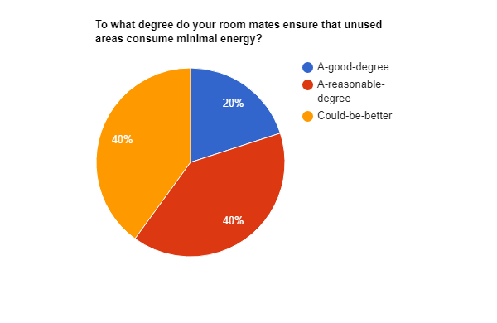

**How communicative/collaborative are you currently with your household members?**

P1: Not very communicative or collaborative

P2: Not communicative or collaborative, absolute minimal

P3: Reasonably communicative, pretty collaborative.

P4: Not very communicative or collaborative

P5: Not very communicative or collaborative

P6: Somewhat communicative and collaborative

P7: Very communicative and collaborative

P8: Very communicative and collaborative

P9: Very communicative and collaborative

P10: Not very communicative or collaborative

